**D-Crypt User Guide**

*by Ko Jia Ling*

# Introduction

D-Crypt is a web-based Python application that aims to enhance the learning of selected cryptography topics. It provides cryptography tools for encryption and decryption, as well as explanations on cryptography theory.

# Programs/Modules Required

* Python (python-3.7.0-amd64.exe) ([Download here](https://www.python.org/downloads/release/python-370/))
* PyCryptodome (version 3.9.7)
* Flask (version 1.1.2)
* WTForms (version 2.3.9)

If you do not have all programs and modules installed, please refer to the Installation guide.

# Table of Content

Introduction 1

Programs/Modules Required 1

Table of Content 1

Starting the Application 2

Home Page/Menu 5

Tools – Default Format 6

Tools – AES 7

Tools – Mono-alphabet Cipher 8

Tools – Rail Fence Technique 9

Tools – Shift Cipher 10

Tools – Simple Columnar Transposition Technique 11

Tools – Vernam Cipher 12

Tools – Diffie-Hellman Key Exchange 13

Learn 14

# Starting the Application

1. Open Command Prompt by searching for “cmd” or “command prompt”.

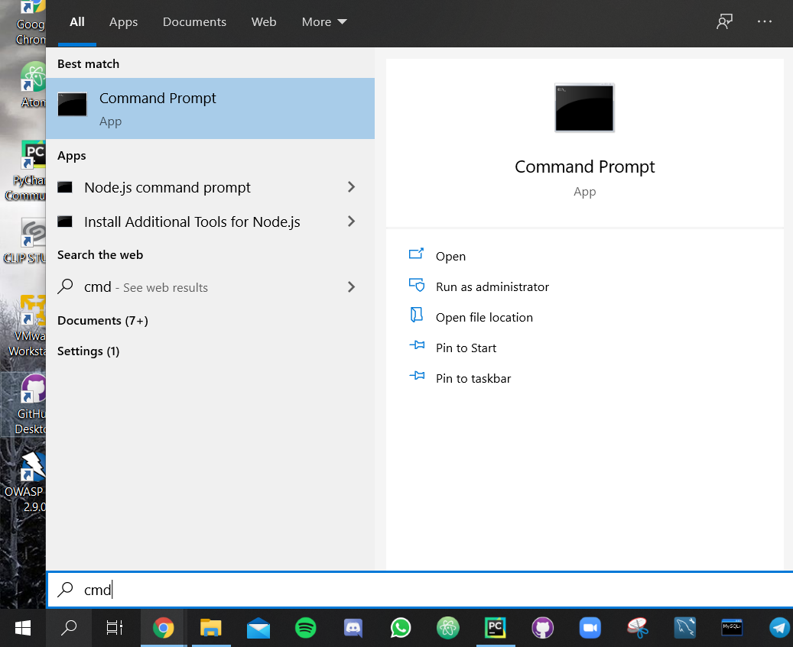

1. Use the change directory (cd) command to navigate to the folder where you downloaded the application.

Open File Explorer and navigate to the place that you saved the application folder. From the breadcrumb, you can determine the path to the project. In this example, the path will be C:\Users\Jialing\Documents\GitHub\D-Crypt

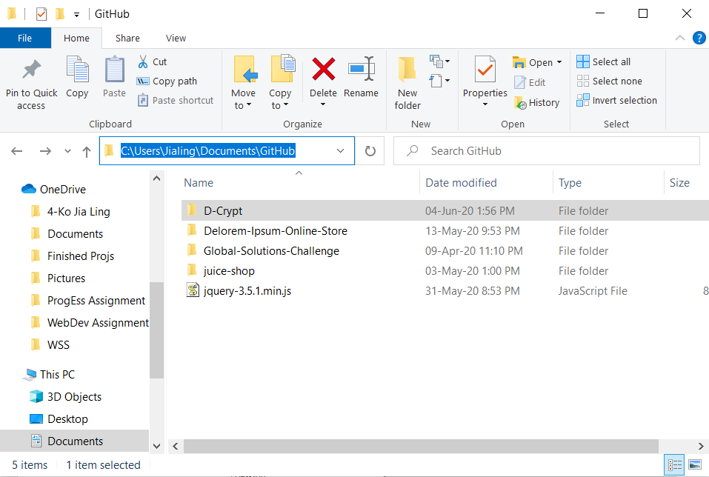

1. Enter the command “cd [insert path here]” into the command line. There should be a change in the path at the start of each line.

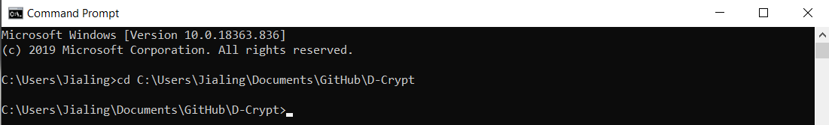

1. Run D-Crypt main.py by using the command python D-Crypt/main.py. You should see the following message in the console.

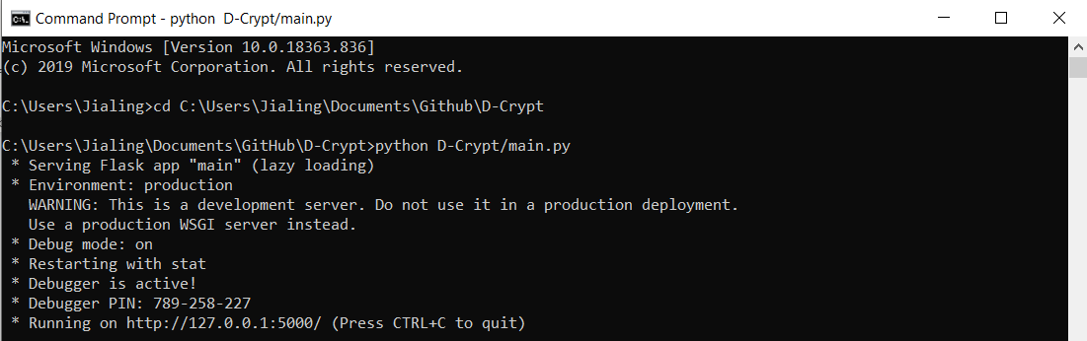

1. Open a browser and visit <http://127.0.0.1:5000/>

# Home Page/Menu

Route: <http://127.0.0.1:5000/home>

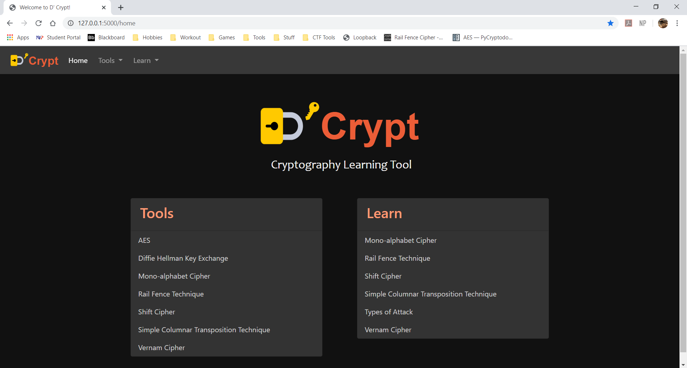

The home page/menu is the landing page upon accessing application.

The page contains a navigation pane for all Tools and Learning materials.

# Tools – Default Format

Route: http://127.0.0.1:5000/learn/[tool name]

Most of the tools (except Diffie-Hellman Key Exchange) will have an Input and Output box. How it works is as follows:

1. Enter the plaintext/ciphertext into the Input box.
2. Click either the Encrypt or Decrypt button.
3. The generated plaintext/ciphertext will appear in the Output box.
4. Click on the Copy Output to Clipboard button to copy the output.

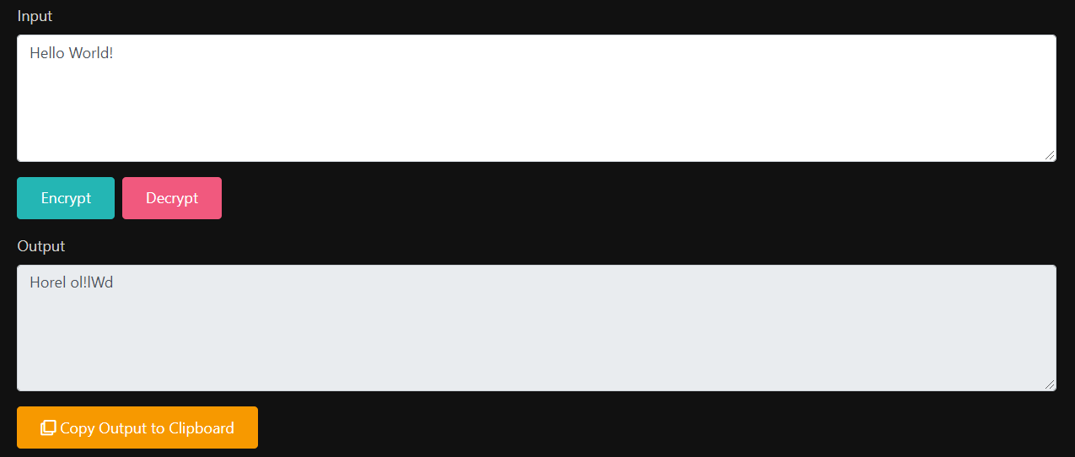

# Tools – AES

Route: <http://127.0.0.1:5000/cipher/aes>

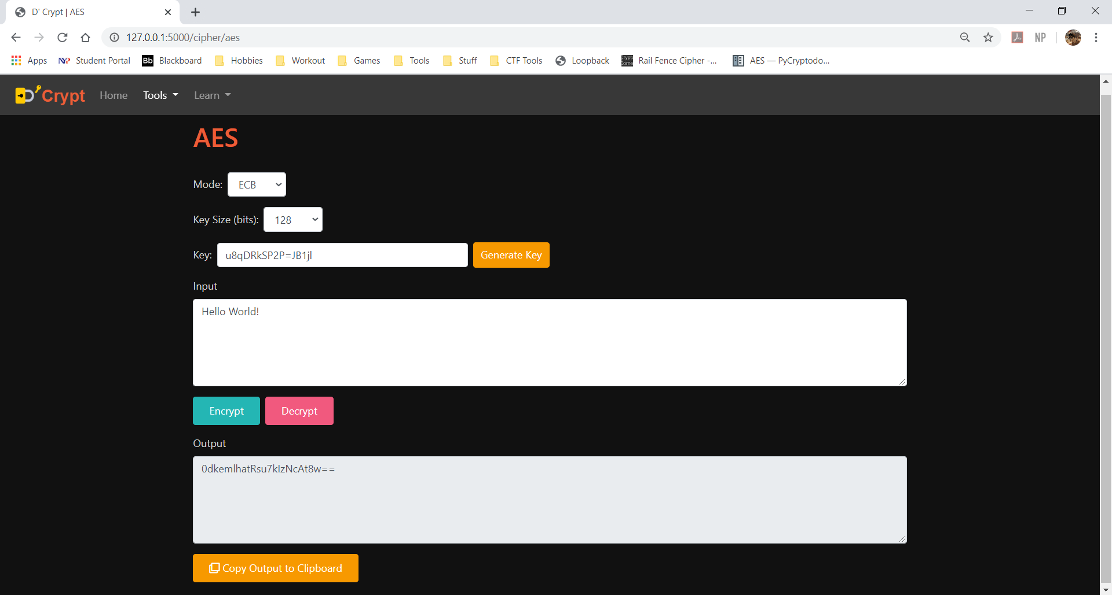

Function: Encrypts/Decrypts text using AES.

4 modes available:

1. Electronic Code Book (ECB)
2. Cipher Block Chaining (CBC)
3. Cipher Feedback (CFB)
4. Output Feedback (OFB)

3 Key sizes:

1. 128 bits (16 bytes)
2. 192 bits (24 bytes)
3. 256 bits (32 bytes)

Initialization Vector (IV) size: 128 bits

IV is only applicable for CBC, CFB and OFB mode.

# Tools – Mono-alphabet Cipher

Route: <http://127.0.0.1:5000/cipher/mono-alphabet-cipher>

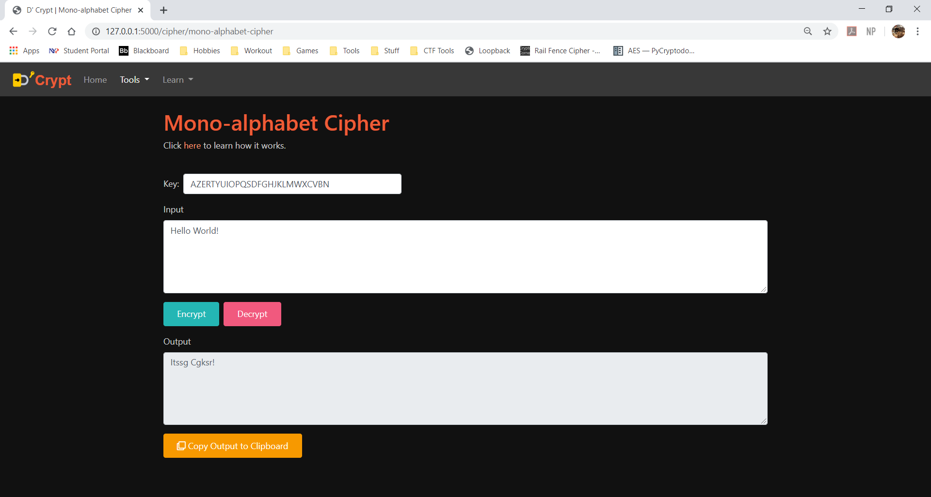

Function: Encrypts/Decrypts text using Mono-alphabet Cipher. Note that this tool does not encrypt/decrypt special characters and spaces.

Conditions for Key:

* Key must contain all 26 letters of the alphabet.
* Key should not have repeating letters. (i.e. there should not be more than one ‘A’, ‘B’ etc.)

# Tools – Rail Fence Technique

Route: <http://127.0.0.1:5000/cipher/rail-fence-technique>

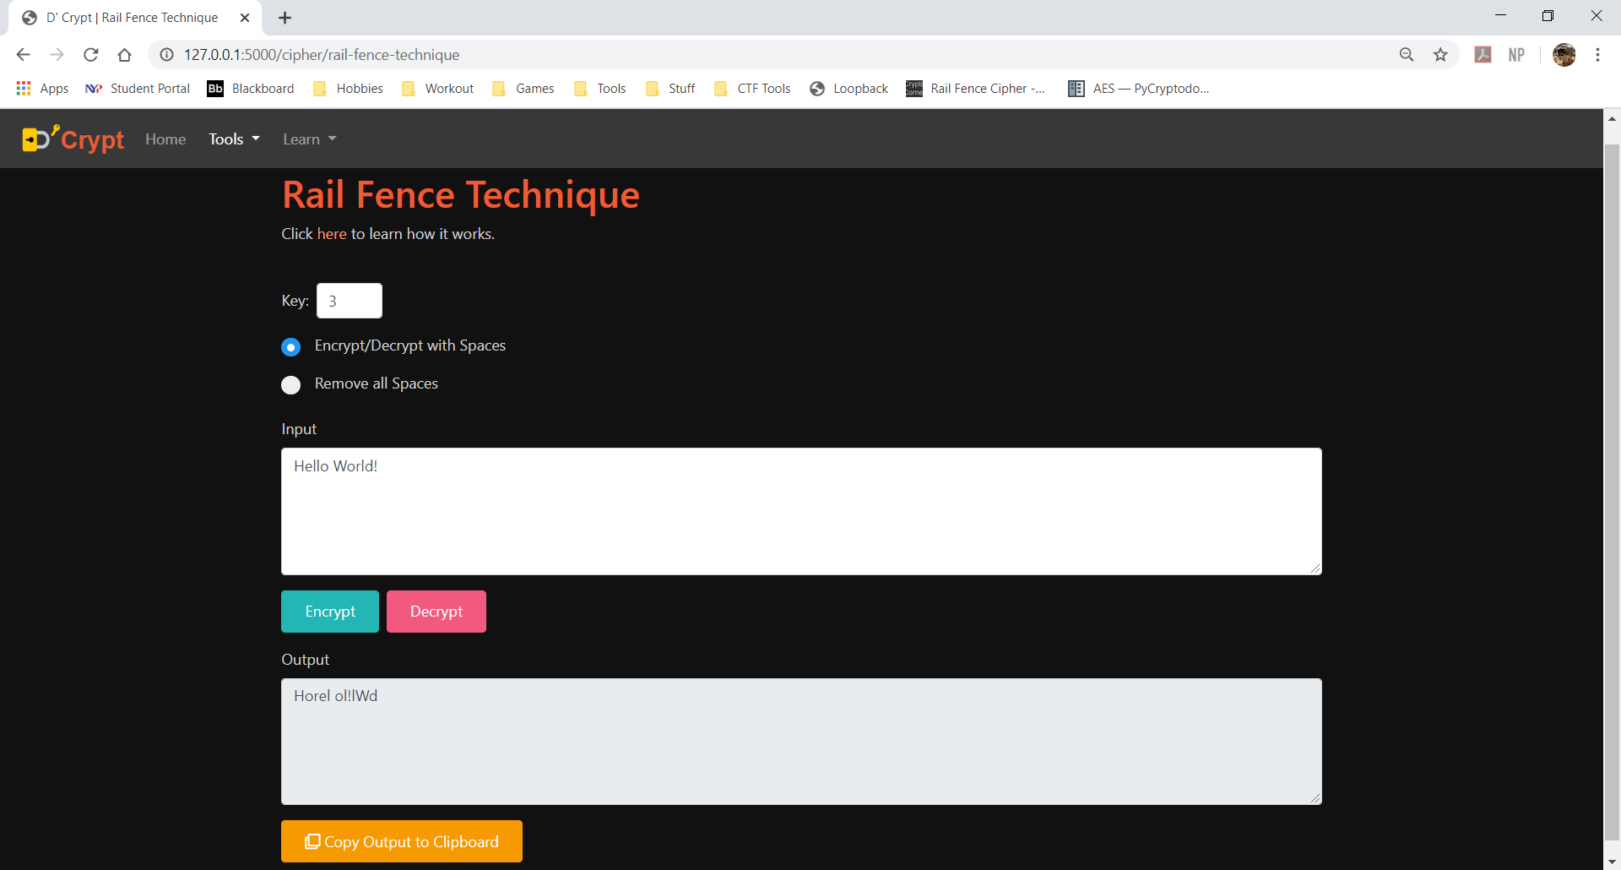

Function: Encrypts/Decrypts text using Rail Fence Technique.

Conditions for Key:

* Minimum value of 2.
* Maximum value of 1000.

2 modes:

1. Encrypt/Decrypt with Space
2. Remove all Spaces

# Tools – Shift Cipher

Route: <http://127.0.0.1:5000/cipher/shift-cipher>

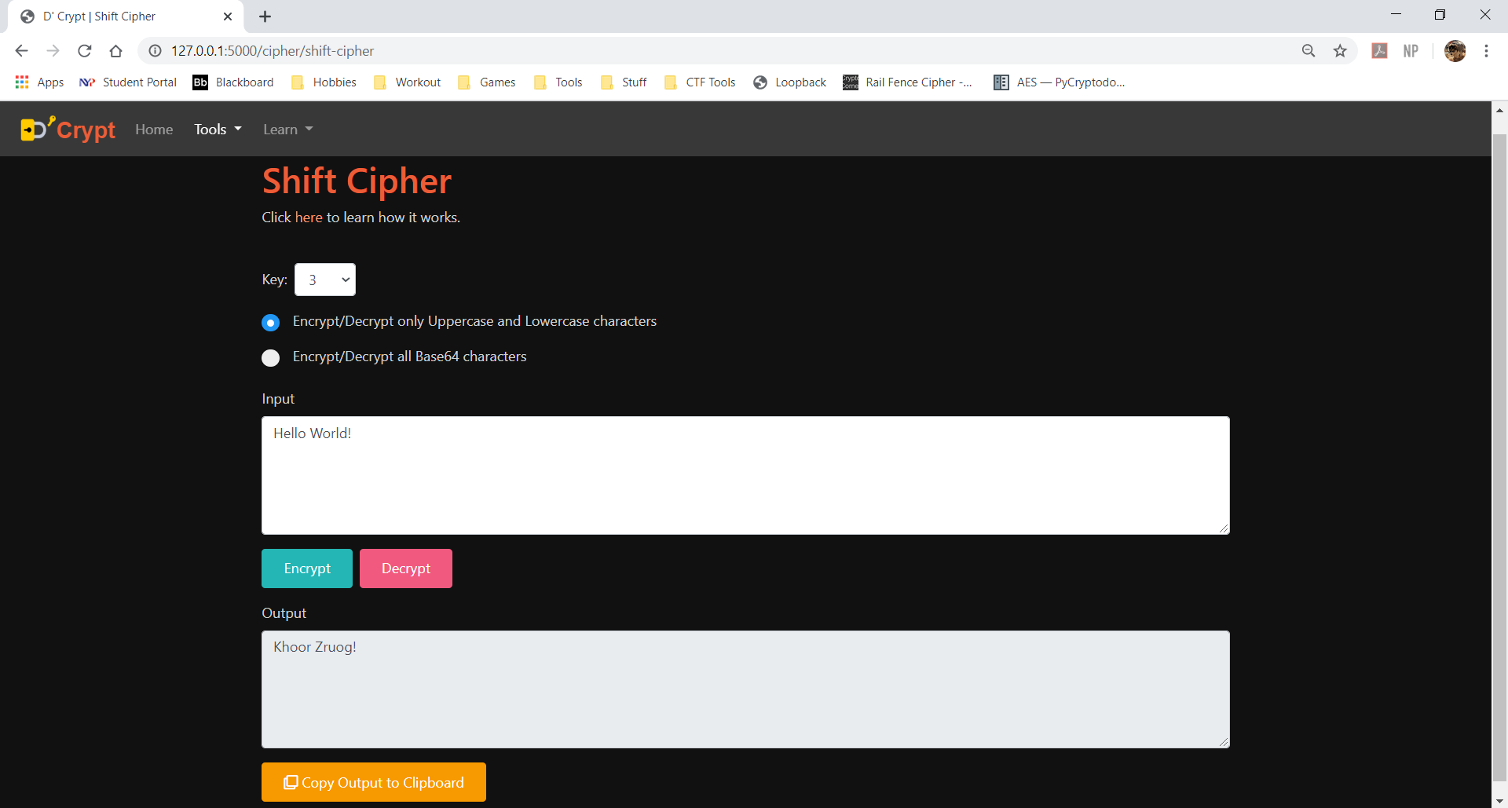

Function: Encrypts/Decrypts text using Shift Cipher.

Conditions for Key:

* Minimum value of 1.
* Maximum value of 26.

2 modes:

1. Encrypt/Decrypt only Uppercase and Lowercase characters (i.e. only alphabets)
2. Encrypt/Decrypt all Base64 characters.

# Tools – Simple Columnar Transposition Technique

Route: <http://127.0.0.1:5000/cipher/simple-columnar-transposition-technique>

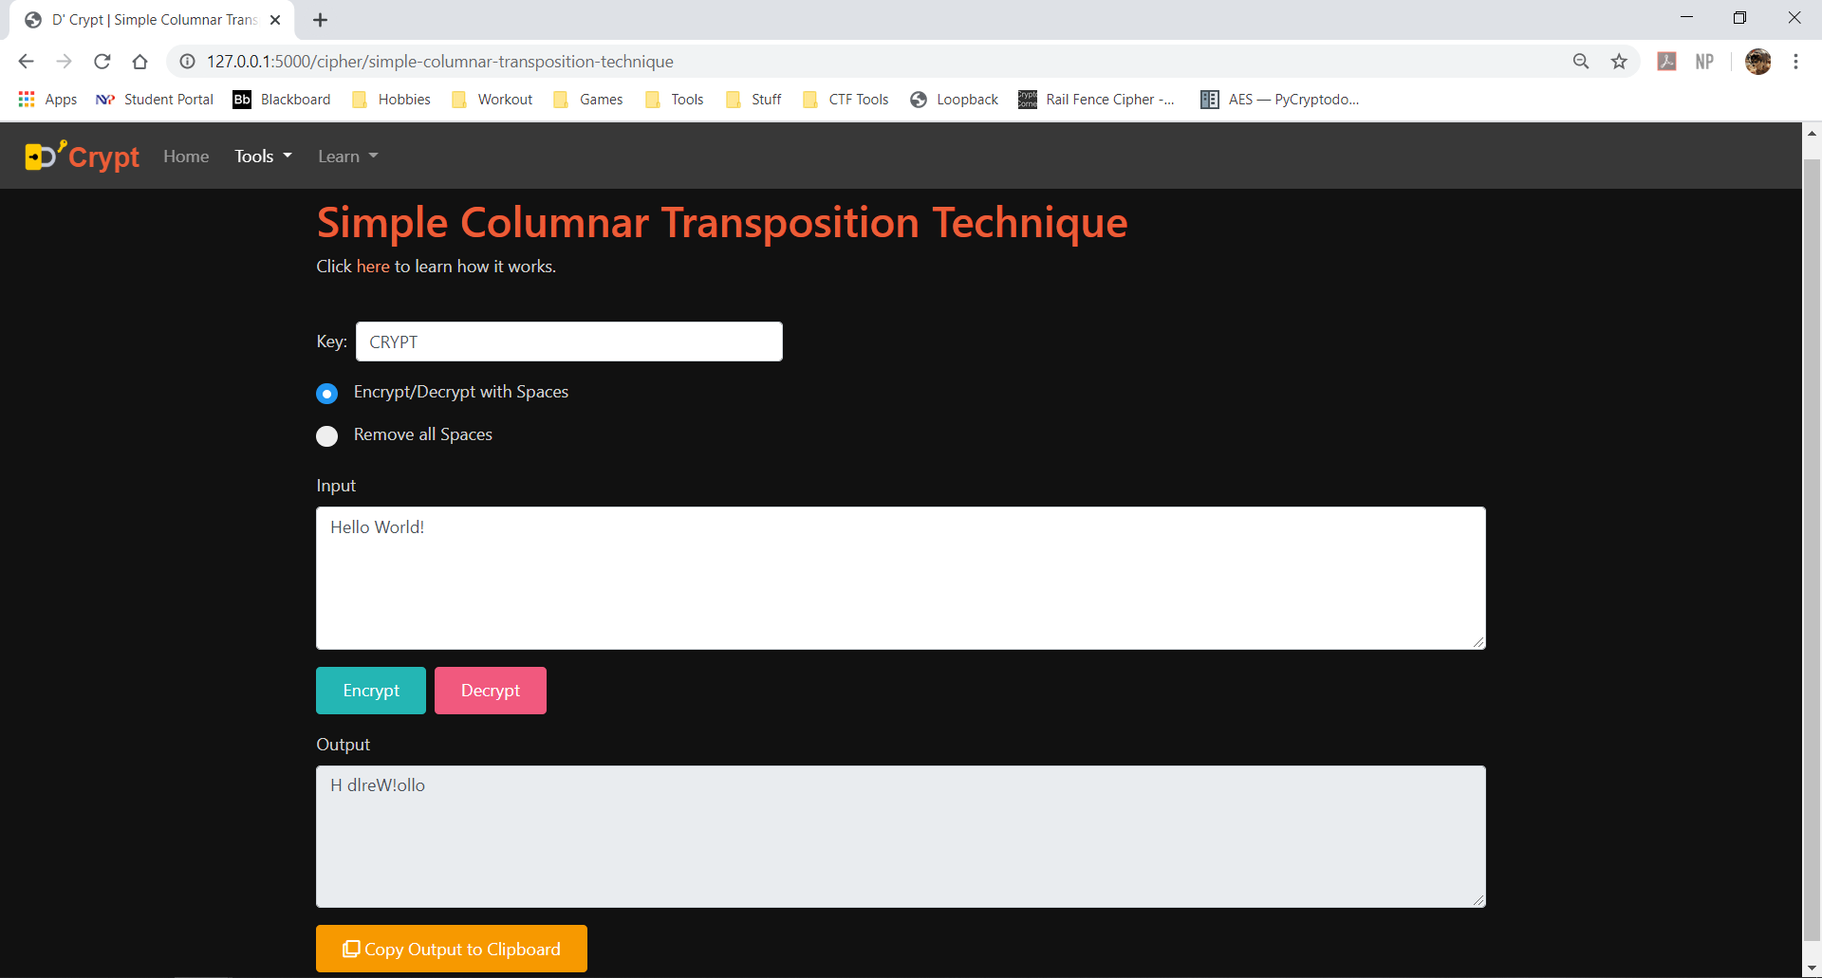

Function: Encrypts/Decrypts text using Simple Columnar Transposition Technique.

Conditions for Key:

* Only accepts alphanumeric values. (i.e. A-Z, a-z, 0-9)

2 modes:

1. Encrypt/Decrypt with Space
2. Remove all Spaces

# Tools – Vernam Cipher

Route: <http://127.0.0.1:5000/cipher/vernam-cipher>

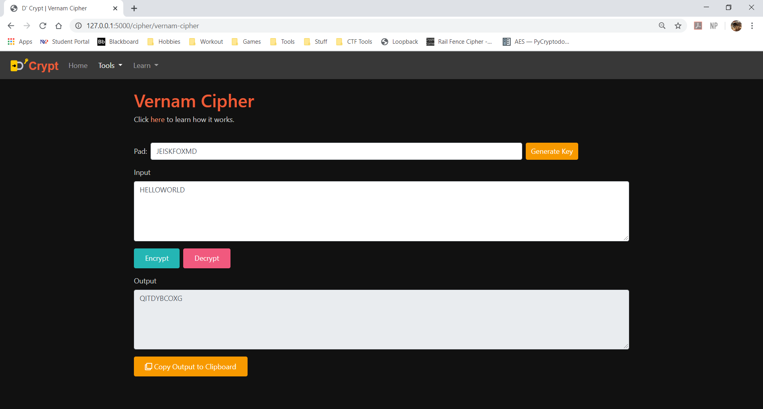

Function: Encrypts/Decrypts text using Vernam Cipher.

Conditions for Pad:

* Must be of equal length as input text.
* Only contain alphabets (uppercase and lowercase letters).

Conditions for Input:

* Must be of equal length as pad.
* Only contain alphabets (uppercase and lowercase letters).

# Tools – Diffie-Hellman Key Exchange

Route: <http://127.0.0.1:5000/cipher/diffie-hellman-key-exchange>

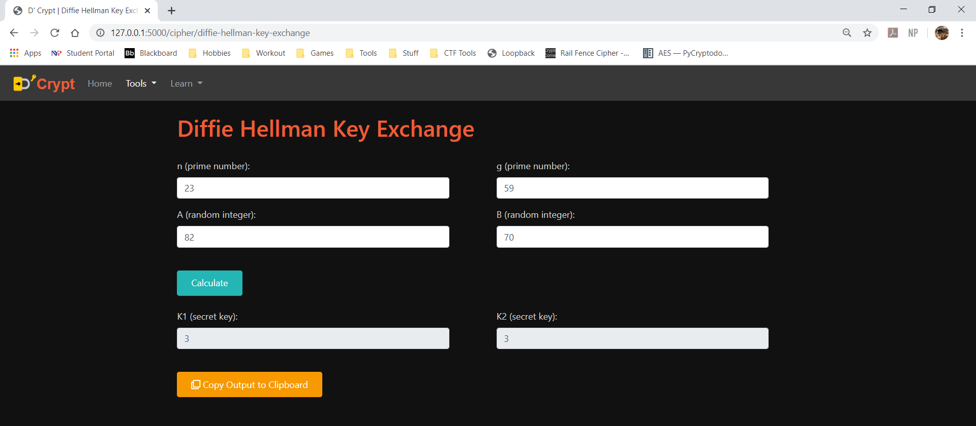

Function: Calculate key based on Diffie-Hellman Key Exchange.

Conditions for n and g:

* Must be prime numbers.

Conditions for A and B:

* Must be whole numbers (0 and above).

# Learn

Route: http://127.0.0.1:5000/learn/[topic]

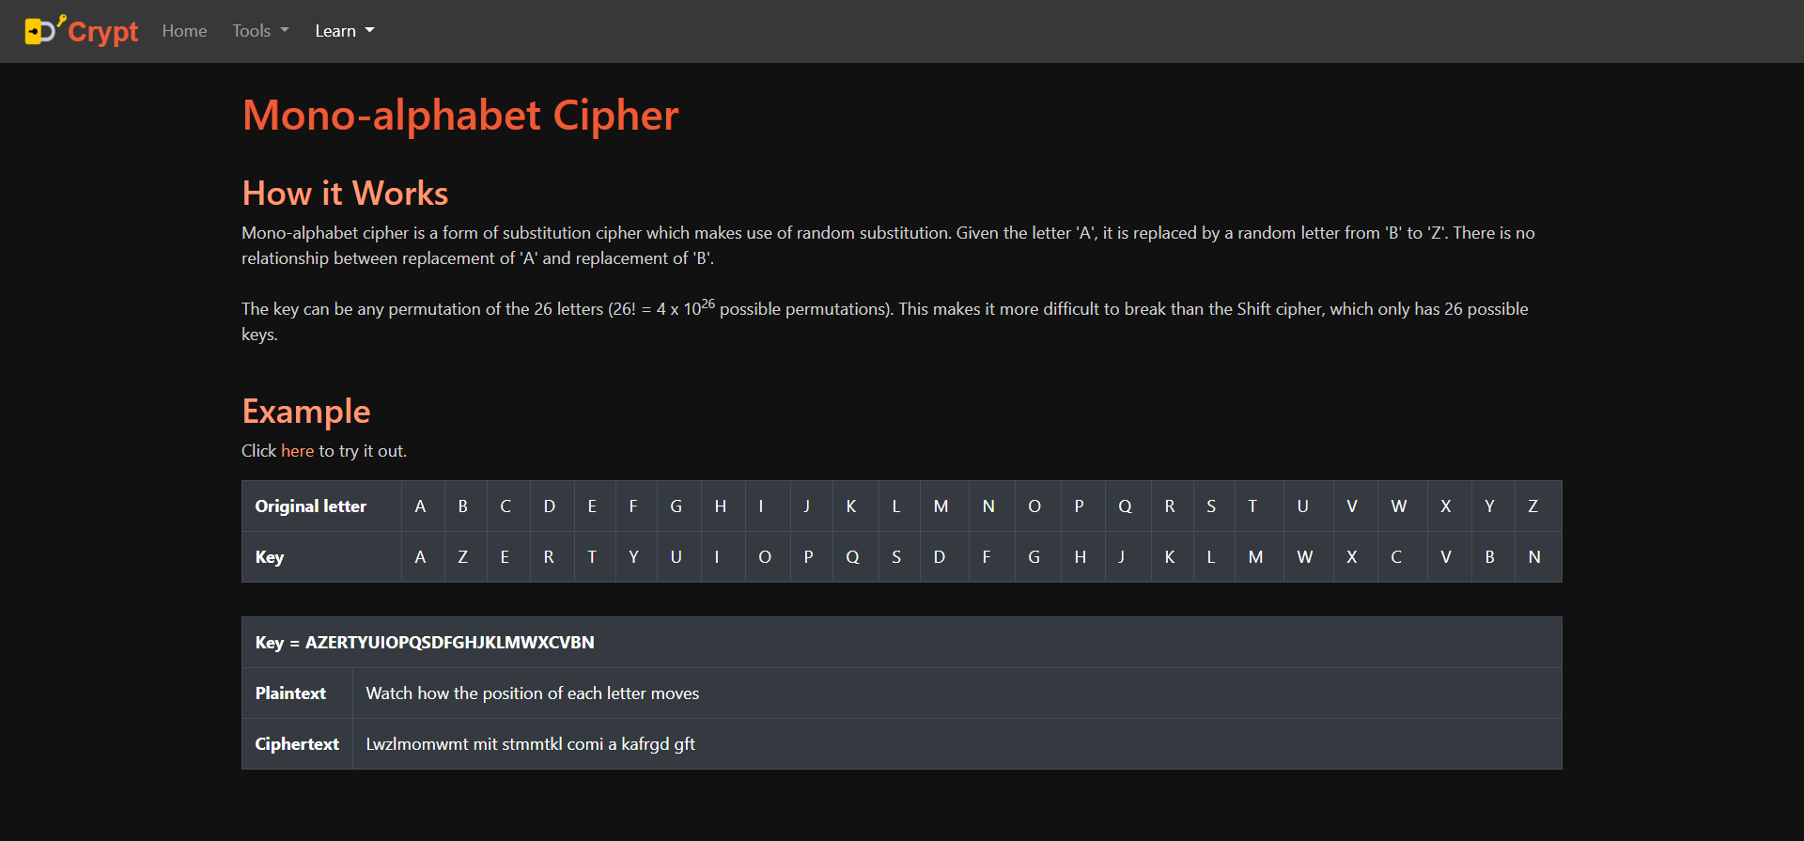

Pages under the “Learn” section provides explanations about various cryptography topics.